MRU | Department of Computer Science & Technology, MRU, Faridabad
MRU | Lab-5: Java Database Connectivity (JDBC)
Subject: Advance Java Workshop Subject Code: CSW308B Semester: V

Objectives
• To implement JDBC

CO1, CO2, CO3

Q1. Create a login screen using JDBC. Login should be successful only if user details are existing in the database.
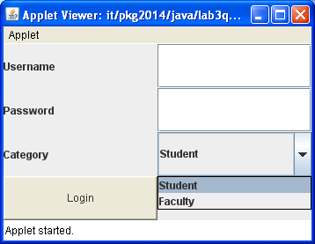

Q2. WAP to perform the following using JDBC:
Search a student using student name and display the details of that particular student

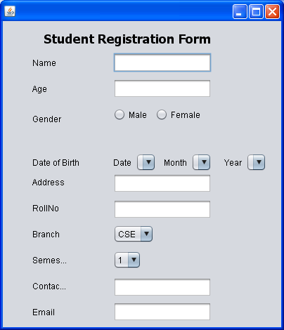

Q3.
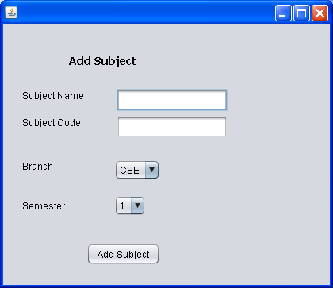
WAP to perform the following using JDBC:
- Add subject information
- Edit subject information
- Remove subject record from database

